Technical seminar report on

# CYBORGS

**By**

**V.SRUTHI 15PQ1A0595**

Internal Guide

# Mr.K.ADHIYA KUMAR

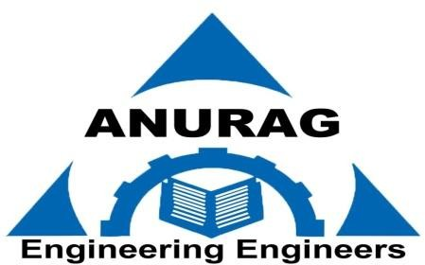

**DEPARTMENT OF COMPUTER SCIENCE AND ENGINEERING**

**ANURAG COLLEGE OF ENGINEERING**

(Approved by AICTE, New Delhi & Affiliated to JNTU-HYD) AUSHAPUR (V), GHATKESAR (M), MEDCHAL DIST, T.S.501301 APRIL 2019